**Final Project Prospectus**

Title: Mapping Lava Tubes

Notice: Dr. Bryan Runck

Author: Grace Walker

Date: 9/28

**Project Repository:** *<if applicable weblink to public repository>*

**Google Drive Link:** *N/A*

**Time Spent:** *10+?*

**Abstract**

The goal of this project is to create a model of flow in lava tubes. It will involve creating an equation to calculate the lava flow velocity where the values for the parameters will come from spatial and other data, plus known constants. Ideally the results of this could be something like a stream network in ArcPro, but it’s unclear still how that will be done. The results in any form could be verified through comparison to real life events. There are still a lot of questions in the project and much research needs to be done.

**Problem Statement**

The goal of this project is to model the flow of lava tubes. A successful and realistic model would be helpful in visualizing and predicting how lava tubes affect lava flows, such as the distances they travel. At minimum, it would ideally model the flow of an already developed tube using simple parameters to describe the flow. Then, once that is successful, the goal would be to add additional complexities to make the model more accurate to reality. It will require python code to calculate and model flow and data to provide values for the calculation. A specific form of data that will probably be useful is DEM or similar data from a volcano such as Kilauea or Mauna Loa.

*Table 1. Project Requirements*

| **#** | **Requirement** | **Defined As** | **(Spatial) Data** | **Attribute Data** | **Dataset** | **Preparation** |
| --- | --- | --- | --- | --- | --- | --- |
| 1 | Flow Equation | Python code which can model the flow of the lava flow. |  |  |  | Research into lava tube mechanics. |
| 2 | Topographic Data | Data which can provide information about slope? | Raster? DEM? |  |  |  |
| 3 | Volcano/Lava properties data. | Data which can fill in other parameters of the flow equation. |  |  |  | Research to figure out where to get this data and how to implement it. |
| 4 |  |  |  |  |  |  |

**Input Data**

One specific form of data that will probably be used is a DEM, or maybe other topographic data. It could be used to provide the slope of the lava tube channel for calculating the velocity of flow, and with a DEM specifically flow direction could maybe also be calculated.

A general category of data that this project requires is data to fulfill other model parameters, such as the initial volume of lava and initial lava temperatures.

*Table 2. Data*

| **#** | **Title** | **Purpose in Analysis** | **Link to Source** |
| --- | --- | --- | --- |
| 1 | Volcano DEM/spatial data | This data is for the slope in the calculation at minimum. | N/A currently |
| 2 | other stuff | Other parameters. | N/A currently |
| 3 |  |  |  |
|  |  |  |  |

**Methods**

The rough concept for the plan for this project is based on an existing model for lava flow, FLOWGO by Harris and Rowland (2001), where they created an equation for the velocity of a channelized lava flow which ran iteratively until velocity equaled zero, at which point the flow would cease. The plan for this project involves creating a similar equation, but with a different coding language and with a different goal as well as different parameters for the equation. The channel geometry would be different, likely a simple tube, and other parameters such as heat loss would be different to apply to lava tubes. Additionally, everything done in this project will start much simpler, and will also involve data used in ArcPro. DEM or similar data used in ArcPro would be used for the slope parameter at the very least, and would ideally be used to create some form of result.

Once a functioning equation that works with the data has been created, complexities such as detailed lava tube mechanics and more detailed parameters which affect flow can be included.

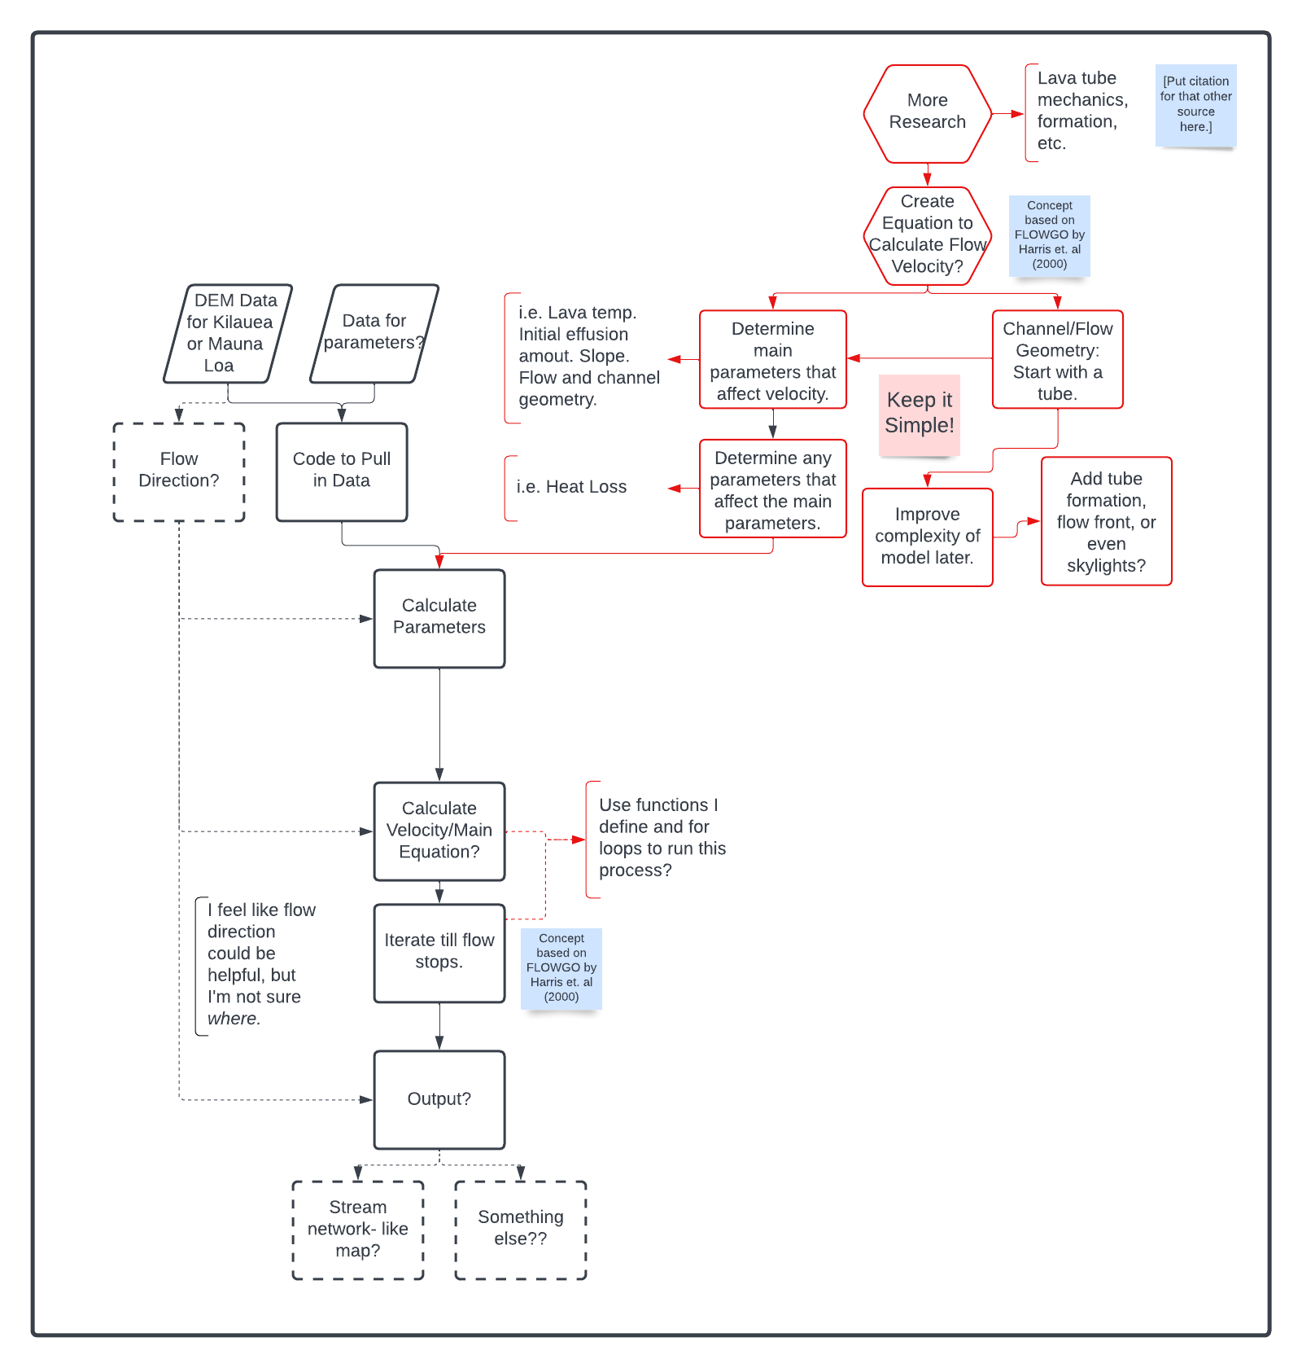

*Figure 1: Flow diagram for both the data in the intended final project and for the process of the project itself currently. Black denotes data flow and red denotes project flow. Dashed lines denote uncertainty.*

**Results**

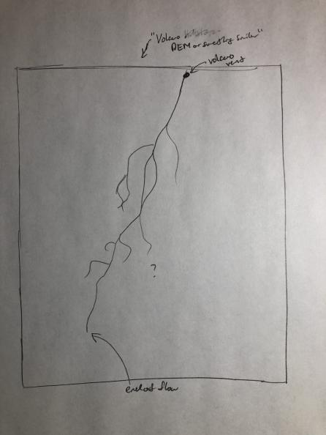

*Figure 1: A sketch of the ideal results of the project, something like a stream network map in ArcPro.*

**Results Verification**

A potential way to verify the results of this data would be to compare the results to any existing data of lava tubes or lava flows involving lava tubes to see how similar they are. Using any data available from a specific historical flow to set some of the parameters could be a good way to directly compare the model to flows in reality.

**Discussion and Conclusion**

This project still has a lot of questions that need to be answered. The exact equation that will be used has yet to be desired, nor have the exact parameters that will be used been determined yet. What the results will actually look like or how to get results that match the ideal goal of the project has not been determined in any way yet either. All of this is going to require a lot more research.

**References**

Harris, A., Rowland, S. (2001) FLOWGO: A Kinematic Thermo-rheological model for lava flows in a channel. *Bulletin of Volcanology, 63*, 20-44.

**Self-score**

*I don’t know if we were actually meant to do this part with the prospectus but I tried to score myself on the prospectus anyway.*

| **Category** | **Description** | **Points Possible** | **Score** |
| --- | --- | --- | --- |
| **Structural Elements** | All elements of a lab report are included **(2 points each)**:  Title, Notice: Dr. Bryan Runck, Author, Project Repository, Date, Abstract, Problem Statement, Input Data w/ tables, Methods w/ Data, Flow Diagrams, Results, Results Verification, Discussion and Conclusion, References in common format, Self-score | 28 | 28 |
| **Clarity of Content** | Each element above is executed at a professional level so that someone can understand the goal, data, methods, results, and their validity and implications in a 5 minute reading at a cursory-level, and in a 30 minute meeting at a deep level **(12 points)**. There is a clear connection from data to results to discussion and conclusion **(12 points)**. | 24 | 18? |
| **Reproducibility** | Results are completely reproducible by someone with basic GIS training. There is no ambiguity in data flow or rationale for data operations. Every step is documented and justified. | 28 | 16? |
| **Verification** | Results are correct in that they have been verified in comparison to some standard. The standard is clearly stated **(10 points)**, the method of comparison is clearly stated **(5 points)**, and the result of verification is clearly stated **(5 points)**. | 20 | ?? |
|  |  | 100 |  |